**1 - Introduction to Processing**

Overview: We are going to learn a new coding language called Processing and we are going to look at what other people have made using Processing.

**STEP 1: WHAT IS PROCESSING?**

Processing is a programming language intended to be used as a simplified way for people to use code in the visual arts. It is very well supported by a large community and has lots of help online to help you fix problems as you go along.

Apart from everything you will learn on this course, you can go to the processing website to explore tutorials and the message boards. http://processing.org

# STEP 2: INSTALLING PROCESSING

software and install it onto your computer.

Get on to the processing website to download the

http://processing.org

Once you’ve installed it, open Processing and you

should have a screen looking like this:

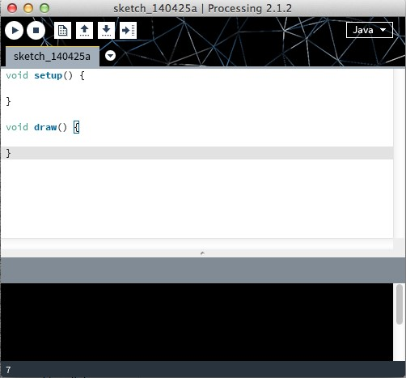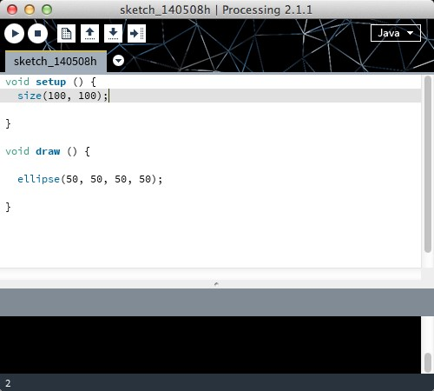

Toolbar

Tabs

Text editor

Message area

Console

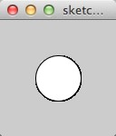

Display Window

Lets take a look at the Processing windows.

The display window opens up when you hit

the Run button on the toolbar.

# STEP 3: FIRST LOOK AT PROCESSING

At the bottom of the screen there’s a black area called the console where we can display messages.

Let’s put an instruction to display a message in setup(). Use this code and click the ‘play’ button to compile:

Can you see “Hello world” in the console?

void setup() {

println(“Hello world”);

}

void draw() {

}

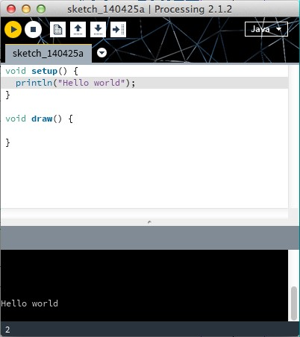

void setup() {

}

void draw() {

println(“Hello world”);

}

Try moving the line of code to the draw() function.

Can you see “Hello world” in the console?

How is it different from the previous step?

# THE DISPLAY WINDOW

Let’s have a look at the display window.

This is where processing will draw what we instruct it to draw.

Let’s first look at how we can set its size:

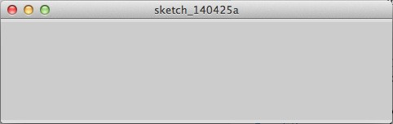void setup() { size(480, 120);

}

void draw() {

}

This will produce a display window that’s 480 pixels wide and 120 pixels high.

Try to change the values to change the size of the window

# STEP 4: PROCESSING EXAMPLES

To see the power of processing and see what we can do with it, we can use the examples folder.

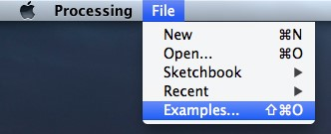Lets start by opening up the examples folder in processing.

Go to the top right handside of the screen and click:

File > Examples

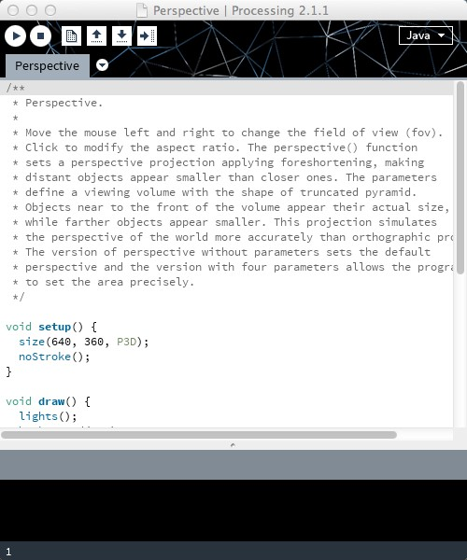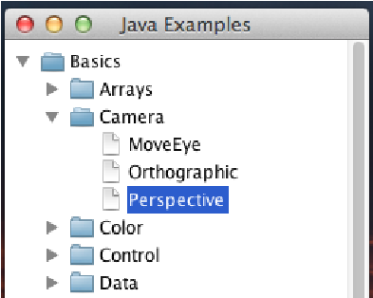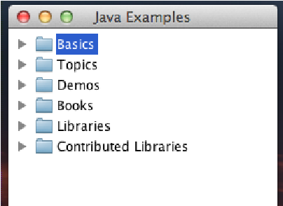Here you will file a great deal of projects to click on and try out straight away.

Lets start with click through to the Perspective example:

Basics > Camera > Perspective

When you first open it up you will see a lot of writing at the top od the sketch.

The first two lines of instructions say:

* Move the mouse left and right to change the field of view
* Click to modify the aspect ratio.

These are instructions are there so you can understand the code.

If you scroll down the code, at first this seems complicated, for now we will not worry about that, and we will just hit the Run button.

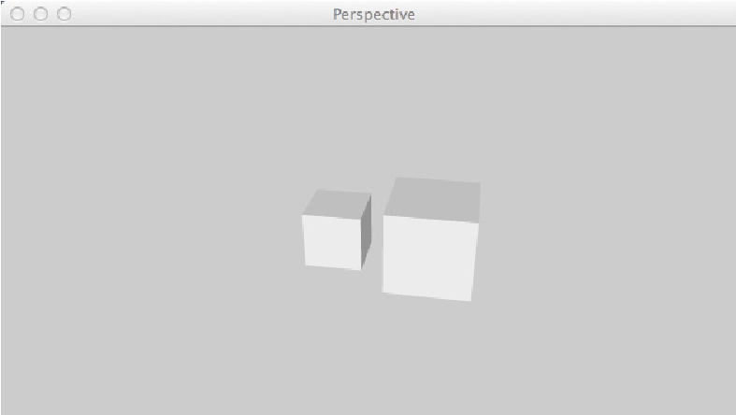If you hit the run button the sketch window will open and you will be presented with two cubes.

 The RUN button

What happens when you move the mouse around?

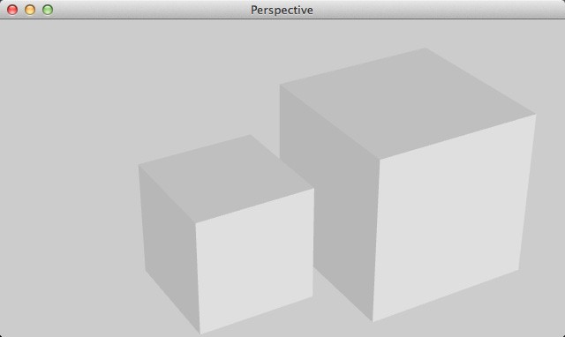Although the code is quite complicated, with a little bit of exploring you’ll learn what things do quickly.

In the code it says:

if (mousePressed) {

aspect = aspect / 2.0;

}

Simply, when the mouse is pressed we know somthing should change. Try it for yourself.

# STEP 5: OTHER PROCESSING EXAMPLES

Check out the other examples in the folder, there ScaleShape

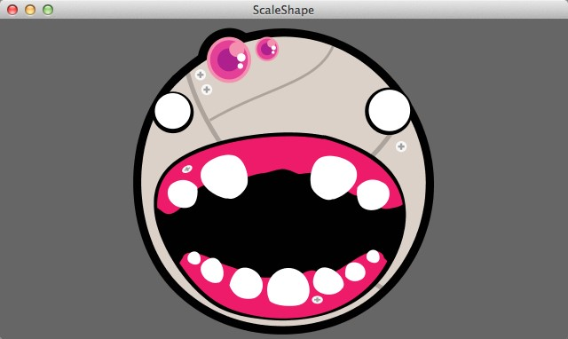are plenty to look into and you can find many more

These two examples can be found in the example folder under: Basics > Shape > ScaleShape

Basics > Color > Hue

## Hue

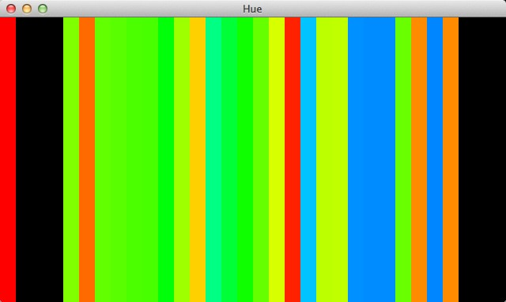Look online: http://www.openprocessing.org/browse/

Did you find any cool projects, do they give you any ideas what you’d like to make with Processing.